Experiment No:1
Roll No:24141056

Title:
Binary search techniques using array and recursion. Analyse time and space
complexity
Theory:
Binary Search is an efficient searching algorithm used to find the position of a target element within a sorted array. It works on the divide and conquer principle.
In this technique, the middle element of the array is compared with the target element:
- If the target equals the middle element → the search is successful.
- If the target is smaller → search continues in the left half.
- If the target is larger → search continues in the right half.
This process is repeated until the element is found or the search space becomes empty.
Binary search can be implemented in two ways:
- Iterative Approach: Uses loops to divide the array repeatedly.
- Recursive Approach: The function calls itself with a smaller portion of the array until the base condition is met.
Algorithm (Recursive Binary Search):
- Start with two indices: low = 0 and high = n - 1.
- Find the middle index: mid = (low + high) / 2.
- If arr[mid] == key, return mid (element found).
- If arr[mid] > key, recursively search in the left subarray (low to mid - 1).
- Else, recursively search in the right subarray (mid + 1 to high).
- If low > high, return -1 (element not found).
Time Complexity:
Case | Complexity | Explanation
Best Case= | O(1) | (Target found at the middle element.)
Average Case= | O(log n) | (Array is divided in half each time.)
Worst Case= | O(log n) | (Target is absent or found after maximum divisions.)

Space Complexity:
- Iterative version: O(1) (no extra memory used).
- Recursive version: O(log n) (due to recursive function call stack).
Programm:
#include <stdio.h>
int binarySearch(int arr[], int low, int high, int key) {
if (low <= high) {
int mid = (low + high) / 2;
if (arr[mid] == key)
return mid;
else if (key < arr[mid])
return binarySearch(arr, low, mid - 1, key);
else
return binarySearch(arr, mid + 1, high, key);
}
return -1;
}
int main() {
int n, key, i, result;
int arr[50];
printf("Enter number of elements: ");
scanf("%d", &n);
printf("Enter %d sorted elements:\n", n);
for (i = 0; i < n; i++)
scanf("%d", &arr[i]);
printf("Enter element to search: ");
scanf("%d", &key);
result = binarySearch(arr, 0, n - 1, key);
if (result == -1)
printf("Element not found.\n");
else
printf("Element found at index: %d\n", result);
return 0;
}
Output:
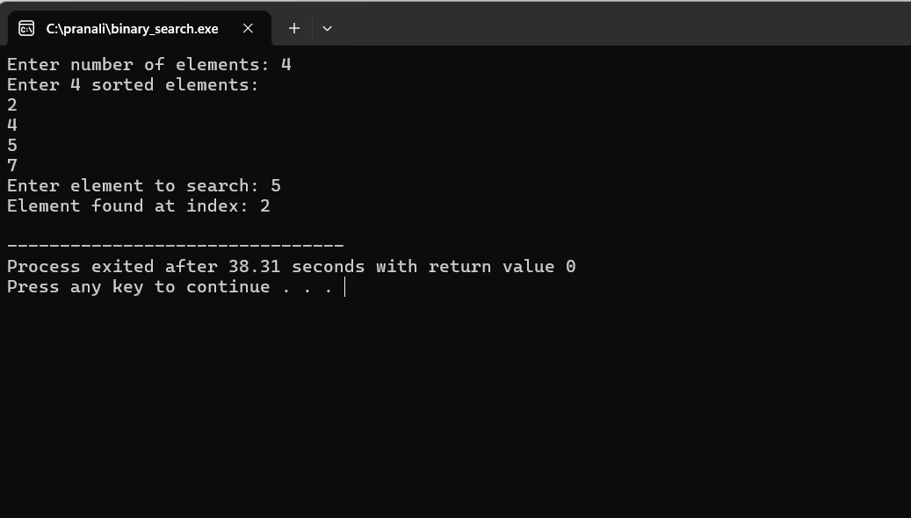

Advantages:
- Very efficient for large datasets (faster than linear search).
- Fewer comparisons due to divide-and-conquer.
- Easy to implement using both iterative and recursive methods.
- Predictable logarithmic time complexity.
Disadvantages:
- Works only on sorted arrays.
- Requires random access (not suitable for linked lists).
- The recursive method may lead to stack overflow for very large input sizes.
- Slightly complex compared to linear search.
Applications:
- Searching elements in sorted datasets (e.g., dictionaries, databases).
- Used in computer graphics, data compression, and optimization problems.
- Applied in searching algorithms like finding square roots, or finding the first/last occurrence of elements.
- Used in libraries and compilers for symbol table lookups.
Conclusion:
Binary Search is a highly efficient searching algorithm that significantly reduces the number of comparisons compared to linear search. When applied to sorted arrays, it provides excellent performance with logarithmic time complexity. The recursive approach offers clear and elegant implementation, though it requires extra space for function calls.

Experiment No. 2
Roll No:24141056
Title:
Quick Sort and Merge Sort using Array as a Data Structure
Theory:
Sorting is the process of arranging data in a particular order (ascending or descending).
Two popular and efficient divide-and-conquer sorting algorithms are Quick Sort and Merge Sort.
1.Quick Sort:
Quick Sort works by selecting a pivot element and partitioning the array such that:
- Elements less than pivot are placed to its left.
- Elements greater than pivot are placed to its right.
Then, the same process is recursively applied to the left and right subarrays until the entire array is sorted.
Working Steps:
- Choose a pivot element.
- Partition the array around the pivot.
- Recursively apply quick sort to the left and right partitions.
- Combine the results.
2. Merge Sort:
Merge Sort divides the array into two halves, sorts them individually, and then merges the two sorted halves into one sorted array.
Working Steps:
- Divide the array into two halves.
- Recursively sort both halves.
- Merge the two sorted halves into a single sorted array.
Algorithm:
A. Quick Sort Algorithm:
- If low < high:
a. Partition the array using a pivot.
b. Recursively sort the left and right subarrays.
B. Merge Sort Algorithm:
- If low < high:
a. Find middle index mid = (low + high)/2.
b. Recursively call merge sort for left half (low to mid).
c. Recursively call merge sort for right half (mid+1 to high).
d. Merge the two halves using the merge function.
Time Complexity Analysis
Algorithm | Best Case | Average Case | Worst Case | Space Complexity
Quick Sort | O(n log n) | O(n log n) | O(n²) | O(log n)
Merge Sort | O(n log n) | O(n log n) | O(n log n) | O(n)

Quick Sort Program:
#include <stdio.h>
void quickSort(int arr[], int low, int high) {
if (low < high) {
int i = low, j = high, pivot = arr[low], temp;
while (i < j) {
while (arr[i] <= pivot && i <= high)
i++;
while (arr[j] > pivot)
j--;
if (i < j) {
temp = arr[i];
arr[i] = arr[j];
arr[j] = temp;
}
}
arr[low] = arr[j];
arr[j] = pivot;
quickSort(arr, low, j - 1);
quickSort(arr, j + 1, high);
}
}
int main() {
int n, i;
int arr[50];
printf("Enter number of elements: ");
scanf("%d", &n);
printf("Enter %d elements:\n", n);
for (i = 0; i < n; i++)
scanf("%d", &arr[i]);
quickSort(arr, 0, n - 1);
printf("Sorted array (Quick Sort):\n");
for (i = 0; i < n; i++)
printf("%d ", arr[i]);
return 0;
}
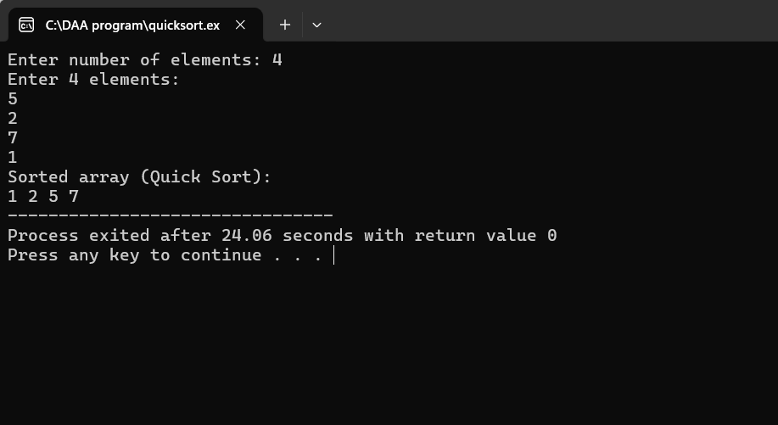
Merge Sort Proram:
#include <stdio.h>
void merge(int arr[], int low, int mid, int high) {
int i = low, j = mid + 1, k = 0;
int temp[50];
while (i <= mid && j <= high) {
if (arr[i] < arr[j])
temp[k++] = arr[i++];
else
temp[k++] = arr[j++];
}
while (i <= mid)
temp[k++] = arr[i++];
while (j <= high)
temp[k++] = arr[j++];
for (i = low, k = 0; i <= high; i++, k++)
arr[i] = temp[k];
}
void mergeSort(int arr[], int low, int high) {
if (low < high) {
int mid = (low + high) / 2;
mergeSort(arr, low, mid);
mergeSort(arr, mid + 1, high);
merge(arr, low, mid, high);
}
}
int main() {
int n, i;
int arr[50];
printf("Enter number of elements: ");
scanf("%d", &n);
printf("Enter %d elements:\n", n);
for (i = 0; i < n; i++)
scanf("%d", &arr[i]);
mergeSort(arr, 0, n - 1);
printf("Sorted array (Merge Sort):\n");
for (i = 0; i < n; i++)
printf("%d ", arr[i]);
return 0;
}
Output:
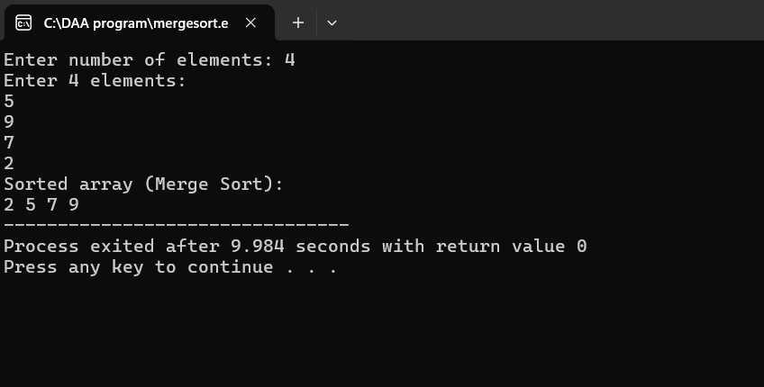
Advantages:
Quick Sort:
- Faster in practice for large datasets.
- In-place sorting (requires less memory).
- Good average performance.
Merge Sort:
- Stable sorting algorithm.
- Guaranteed O(n log n) performance.
- Works well for large linked data structures.
Disadvantages:
Quick Sort:
- Worst case O(n²) when pivot is poorly chosen.
- Recursive calls may cause stack overflow.
Merge Sort:
- Requires additional memory for temporary arrays.
- More complex implementation.
Applications:
- Used in sorting libraries and frameworks.
- Employed in databases, search algorithms, and file systems.
- Merge sort is used for sorting linked lists and large datasets.
- Quick sort is used in systems where in-place sorting is preferred.
Conclusion:
Quick Sort performs sorting in-place with good average performance, while Merge Sort provides stable and predictable sorting at the cost of extra space. Both have O(n log n) time complexity on average and are widely used in computer science applications.
Experiment No. 3:
Roll No:24141056

Title:
Knapsack problem using Greedy method.
Theory:
The Knapsack Problem is a classical optimization problem where we must select a subset of items, each with a profit (value) and weight, to maximize the total profit without exceeding the knapsack’s capacity.
There are two types of knapsack problems:
- 0/1 Knapsack Problem: Each item can either be taken or not (no fraction allowed).
- Fractional Knapsack Problem: Items can be broken into smaller parts; fractions of items can be taken to maximize the total profit.
The Greedy method is used to solve the Fractional Knapsack Problem efficiently.
It selects items based on the highest profit-to-weight ratio (Pi/Wi) first.
Working Principle:
- Compute the profit/weight ratio for each item.
- Sort all items in descending order of this ratio.
- Add items to the knapsack until it is full.
- If the next item cannot fit completely, take only the fractional part that fits.
- Stop when the knapsack reaches its capacity.
Algorithm:
- Start
- Input the number of items n and the knapsack capacity m.
- For each item i, input profit p[i] and weight w[i].
- Calculate ratio r[i] = p[i] / w[i].
- Sort items in descending order of ratio r[i].
- Initialize totalProfit = 0 and remainingCapacity = m.
- For each item:
  - If w[i] <= remainingCapacity, add the full item.
  - Else take a fraction of the item.
- Display total profit.
- Stop.
Time and Space Complexity:
Operation | Complexity
Sorting items | O(n log n)
Selection process | O(n)
Total Time Complexity | O(n log n)
Space Complexity | O(n)

Program :
#include <stdio.h>
void knapsack(int n, float weight[], float profit[], float capacity) {
float x[20], tp = 0;
int i, j, u;
float ratio[20], temp;
u = capacity;
for (i = 0; i < n; i++)
ratio[i] = profit[i] / weight[i];
for (i = 0; i < n - 1; i++) {
for (j = i + 1; j < n; j++) {
if (ratio[i] < ratio[j]) {
temp = ratio[j];
ratio[j] = ratio[i];
ratio[i] = temp;
temp = weight[j];
weight[j] = weight[i];
weight[i] = temp;
temp = profit[j];
profit[j] = profit[i];
profit[i] = temp;
}
}
}
for (i = 0; i < n; i++)
x[i] = 0.0;
for (i = 0; i < n; i++) {
if (weight[i] > u)
break;
else {
x[i] = 1.0;
tp = tp + profit[i];
u = u - weight[i];
}
}
if (i < n)
x[i] = u / weight[i];
tp = tp + (x[i] * profit[i]);
printf("\nThe result vector is: ");
for (i = 0; i < n; i++)
printf("%.2f ", x[i]);
printf("\nMaximum profit is: %.2f\n", tp);
}
int main() {
float weight[20], profit[20], capacity;
int num, i;
printf("Enter the number of items: ");
scanf("%d", &num);
printf("Enter weights and profits of each item:\n");
for (i = 0; i < num; i++) {
printf("Weight[%d]: ", i + 1);
scanf("%f", &weight[i]);
printf("Profit[%d]: ", i + 1);
scanf("%f", &profit[i]);
}
printf("Enter the capacity of knapsack: ");
scanf("%f", &capacity);
knapsack(num, weight, profit, capacity);
return 0;
}
Output:
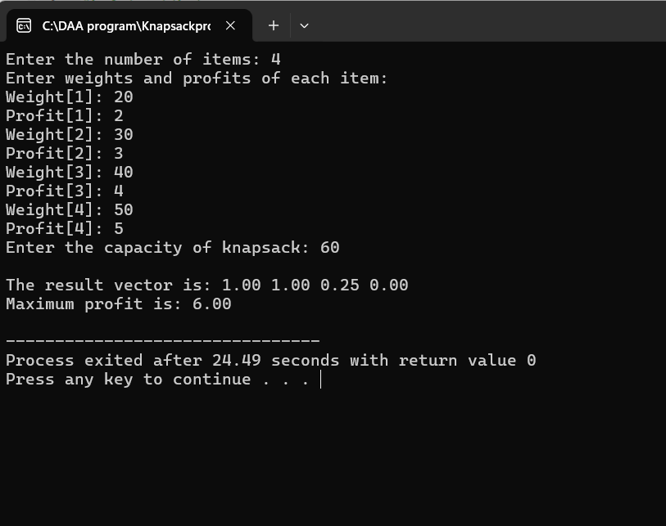
Advantages:
- Easy to implement.
- Produces an optimal solution for the fractional knapsack problem.
- Fast and efficient with O(n log n) performance due to sorting.
Disadvantages:
- Cannot be used for 0/1 Knapsack problem (since items cannot be divided).
- Requires fractional division, which may not be practical in all real-life cases.
Applications:
- Used in resource allocation problems.
- Applied in financial portfolio design (maximizing profit with limited investment).
- Useful in data compression and network bandwidth optimization.
- Applied in job scheduling and project selection problems.
Conclusion:
The Greedy method provides an efficient solution for the Fractional Knapsack Problem by making the locally optimal choice (highest profit-to-weight ratio) at each step. It guarantees a globally optimal solution and is widely used in optimization and resource management problems.

Experiment No. 4
Roll No:24141056

Title:
Greedy method to solve problems of Optimal Merge Pattern.
Theory:
The Optimal Merge Pattern problem is a classic example of the Greedy Method used to minimize the total computation (or merge) cost when combining several sorted files into a single sorted file.
Suppose there are n sorted files of different sizes, and each merge operation between two files takes a time equal to the sum of their sizes. The goal is to find an order of merging that minimizes the total cost.
Working Principle (Greedy Approach):
- Always choose the two smallest files and merge them first.
- Add their combined size (cost) to the total merge cost.
- Insert the merged file back into the list of files.
- Repeat the process until only one file remains.
By always merging the smallest files first, the total merge cost is minimized — this is the Greedy choice property.
Example:
Let file sizes = {20, 30, 10, 5}
Steps:
- Merge 5 and 10 → cost = 15
- Files now: {15, 20, 30}
- Merge 15 and 20 → cost = 35
- Files now: {30, 35}
- Merge 30 and 35 → cost = 65
Total minimum cost = 15 + 35 + 65 = 115
Time and Space Complexity :
Time and Space Complexity:
Case | Time Complexity | Space Complexity
Using Sorting | O(n²) (simple implementation) | O(n)
Using Min-Heap (Optimized) | O(n log n) | O(n)

Algorithm:
- Start
- Input the number of files and their sizes.
- Sort the file sizes in ascending order.
- Repeat until only one file remains:
  - Take two smallest file sizes.
  - Merge them and add the merge cost to total cost.
  - Insert the new merged file size into the list (maintain sorted order).
- Print the total minimum cost.
- Stop.
Program :
#include <stdio.h>
void sort(int arr[], int n) {
int i, j, temp;
for (i = 0; i < n - 1; i++) {
for (j = 0; j < n - i - 1; j++) {
if (arr[j] > arr[j + 1]) {
temp = arr[j];
arr[j] = arr[j + 1];
arr[j + 1] = temp;
}
}
}
}
int main() {
int n, i, j, totalCost = 0;
int files[50];
printf("Enter number of files: ");
scanf("%d", &n);
printf("Enter sizes of files:\n");
for (i = 0; i < n; i++)
scanf("%d", &files[i]);
sort(files, n);
while (n > 1) {
int first = files[0];
int second = files[1];
int mergeCost = first + second;
totalCost += mergeCost;
for (i = 2; i < n; i++)
files[i - 2] = files[i];
files[n - 2] = mergeCost;
n--;
sort(files, n);
}
printf("\nMinimum total merge cost: %d\n", totalCost);
return 0;
}
Output:
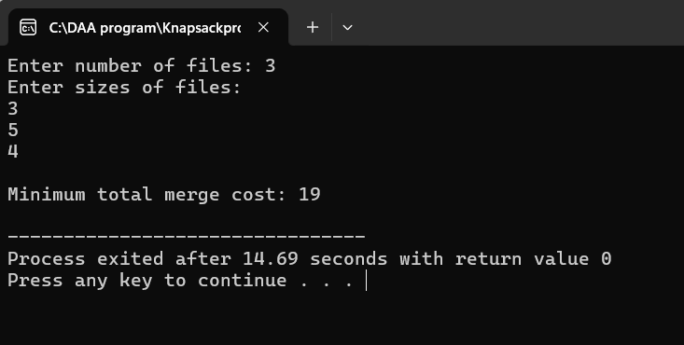
Advantages:
- Provides the minimum total cost for merging operations.
- Simple and efficient using the greedy approach.
- Works well with priority queues (min-heaps) for large datasets.
Disadvantages:
- Sorting is required after each merge if not using a heap.
- For a large number of files, repeated sorting may slow down the algorithm.
- Only works optimally when all merge costs are additive.
Applications:
- External sorting in file systems.
- Data compression (e.g., Huffman coding).
- Merging of sorted datasets in databases.
- Network data merging and log file combination.
Conclusion:
The Optimal Merge Pattern problem demonstrates the power of the Greedy Method in minimizing total merge cost by always merging the smallest files first. It provides an optimal solution with a time complexity of O(n log n) (when using a priority queue) and is widely used in file management and data compression algorithms.

Experiment No:5
Roll No:24141056

Title:
Minimum Cost Spanning Tree of a given undirected graph using Prim’s algorithm and Kruskal's algorithm and compare.
Theory:
A Spanning Tree of a connected, undirected graph is a subgraph that includes all vertices of the graph and is a tree (i.e., it has no cycles).A Minimum Cost Spanning Tree (MST) is a spanning tree where the sum of edge weights is minimum among all possible spanning trees.
Prim’s Algorithm (Greedy Method):
Prim’s algorithm grows the spanning tree by adding one edge at a time from a selected starting vertex, always choosing the minimum weight edge that connects a vertex in the tree to a vertex outside it.
Steps:
- Start from any vertex.
- Select the smallest weight edge connecting the tree to an outside vertex.
- Add that vertex and edge to the tree.
- Repeat until all vertices are included.
Kruskal’s Algorithm (Greedy Method):
Kruskal’s algorithm builds the spanning tree by sorting all edges in non-decreasing order of weight and then adding them one by one, ensuring no cycles are formed (using Union-Find or parent array).
Steps:
- Sort all edges in ascending order of their weight.
- Pick the smallest edge that doesn’t form a cycle.
- Repeat until there are (V–1) edges in the tree.
Complexity :
Algorithm | Time Complexity | Space Complexity | Best Use Case
Prim’s Algorithm | O(V²) (simple array) or O(E log V) (using min-heap) | O(V²) | Dense graphs
Kruskal’s Algorithm | O(E log E) (for sorting) | O(E + V) | Sparse graphs
Where:
- V = Number of vertices
- E = Number of edges
Algorithm:
Prim’s Algorithm:
- Initialize all vertices as unvisited.
- Choose any vertex as the starting vertex.
- While all vertices are not included:
  - Pick the edge with the minimum weight that connects a visited vertex to an unvisited vertex.
  - Mark that vertex as visited.
  - Add the edge to the MST.
- Display the edges and the total cost.
Kruskal’s Algorithm:
- Sort all edges in ascending order of weight.
- Initialize a parent array (for disjoint sets).
- For each edge in sorted order:
  - If it doesn’t form a cycle (i.e., endpoints belong to different sets), include it in MST.
  - Union the sets of the vertices.
- Continue until (V – 1) edges are included.
- Display the MST and total cost.
Program
Prim’s Algorithm
#include <stdio.h>
#define INF 999
int main() {
int n, i, j, min, a, b, u, v;
int visited[10] = {0}, ne = 1, mincost = 0;
int cost[10][10];
printf("Enter number of vertices: ");
scanf("%d", &n);
printf("Enter the adjacency matrix:\n");
for (i = 1; i <= n; i++)
for (j = 1; j <= n; j++) {
scanf("%d", &cost[i][j]);
if (cost[i][j] == 0)
cost[i][j] = INF;
}
visited[1] = 1;
printf("\nEdges of Minimum Cost Spanning Tree using Prim’s Algorithm:\n");
while (ne < n) {
for (i = 1, min = INF; i <= n; i++)
for (j = 1; j <= n; j++)
if (cost[i][j] < min)
if (visited[i] != 0) {
min = cost[i][j];
a = u = i;
b = v = j;
}
if (visited[u] == 0 || visited[v] == 0) {
printf("\nEdge %d: (%d -> %d) cost: %d", ne++, a, b, min);
mincost += min;
visited[b] = 1;
}
cost[a][b] = cost[b][a] = INF;
}
printf("\nMinimum cost = %d\n", mincost);
return 0;
}
Output:
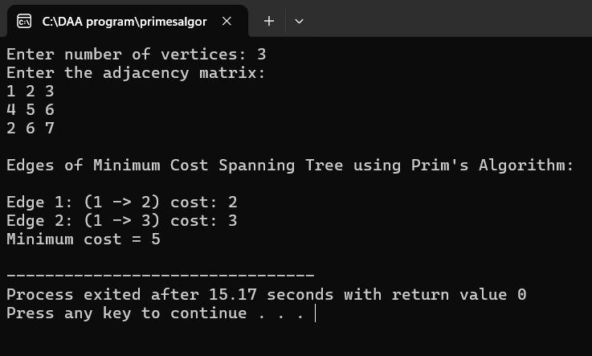
Kruskal’s Algorithm
#include <stdio.h>
#define INF 999
int find(int parent[], int i) {
while (parent[i])
i = parent[i];
return i;
}
int uni(int parent[], int i, int j) {
if (i != j) {
parent[j] = i;
return 1;
}
return 0;
}
int main() {
int cost[10][10], parent[10] = {0};
int n, i, j, ne = 1, min, a, b, u, v, mincost = 0;
printf("Enter number of vertices: ");
scanf("%d", &n);
printf("Enter the adjacency matrix:\n");
for (i = 1; i <= n; i++)
for (j = 1; j <= n; j++) {
scanf("%d", &cost[i][j]);
if (cost[i][j] == 0)
cost[i][j] = INF;
}
printf("\nEdges of Minimum Cost Spanning Tree using Kruskal’s Algorithm:\n");
while (ne < n) {
for (i = 1, min = INF; i <= n; i++)
for (j = 1; j <= n; j++)
if (cost[i][j] < min) {
min = cost[i][j];
a = u = i;
b = v = j;
}
u = find(parent, u);
v = find(parent, v);
if (uni(parent, u, v)) {
printf("\nEdge %d: (%d -> %d) cost: %d", ne++, a, b, min);
mincost += min;
}
cost[a][b] = cost[b][a] = INF;
}
printf("\nMinimum cost = %d\n", mincost);
return 0;
}
Otput:
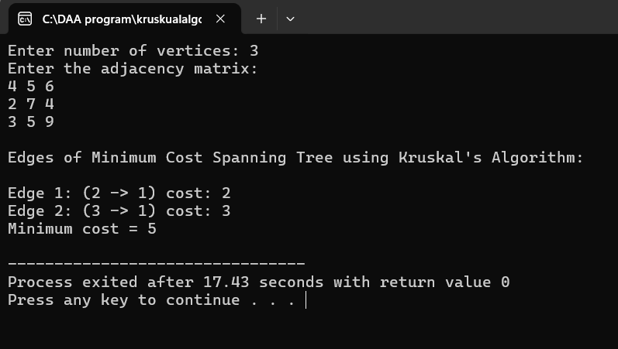

Advantages:
- Both provide optimal solutions for MST.
- Greedy approach ensures minimum total weight.
- Kruskal’s is faster for sparse graphs, Prim’s for dense graphs.
Disadvantages:
- Prim’s requires adjacency matrix, inefficient for large sparse graphs.
- Kruskal’s needs cycle detection, slightly complex to implement.
Applications:
- Network Design (telecommunication, computer, or electrical networks).
- Transportation & Road Systems.
- Cluster analysis in Machine Learning.
- Approximation algorithms (e.g., Traveling Salesman Problem).
Conclusion:
Both Prim’s and Kruskal’s algorithms find the Minimum Cost Spanning Tree effectively using the Greedy Method.
Prim’s is efficient for dense graphs, while Kruskal’s is suitable for sparse graphs.
Both yield the same total minimum cost but differ in their implementation and data structures used.
Experiment No. 6:
Roll No:24141056

Title:
Shortest paths to other vertices using Dijkstra’s Algorithm from a given vertex in a weighted connected graph.
Aim:
To implement Dijkstra’s Algorithm to find the shortest paths from a given source vertex to all other vertices in a weighted, connected graph, and to analyze its time and space complexity.
Theory:
Dijkstra’s Algorithm is a Greedy algorithm used to find the shortest path from a single source vertex to all other vertices in a weighted, connected graph with non-negative edge weights.It continuously selects the vertex with the minimum distance value that has not yet been processed, and updates the distances of its adjacent vertices.
Steps:
- Assign distance = 0 for the source vertex and ∞ for all others.
- Mark all vertices as unvisited.
- Select the unvisited vertex with the smallest tentative distance.
- Update the distances of its adjacent vertices.
- Mark this vertex as visited (processed).
- Repeat until all vertices are visited.
At the end, the distance[] array will store the shortest distance from the source to every vertex.
Complexity Analysis:
Implementation | Time Complexity | Space Complexity
Using Adjacency Matrix | O(V²) | O(V)
Using Min-Heap (Priority Queue) | O(E log V) | O(V + E)
Where V = number of vertices, E = number of edges.
Algorithm (Pseudo Code):
- Initialize distance[] = ∞, visited[] = false.
- distance[source] = 0
- For (V - 1) times:
  - Pick the minimum distance vertex (u) from the set of unvisited vertices.
  - Mark u as visited.
  - For each adjacent vertex v of u:
    - If not visited and distance[u] + weight(u,v) < distance[v], then update distance[v].
- Print the distance array.
Program :
#include <stdio.h>
#define INF 999
void dijkstra(int n, int cost[10][10], int source) {
int dist[10], visited[10] = {0};
int i, j, count, min, next;
for (i = 1; i <= n; i++) {
dist[i] = cost[source][i];
}
visited[source] = 1;
dist[source] = 0;
count = 1;
while (count < n) {
min = INF;
for (i = 1; i <= n; i++) {
if (!visited[i] && dist[i] < min) {
min = dist[i];
next = i;
}
}

visited[next] = 1;
for (i = 1; i <= n; i++) {
if (!visited[i] && (min + cost[next][i] < dist[i])) {
dist[i] = min + cost[next][i];
}
}
count++;
}
printf("\nShortest distances from Source %d:\n", source);
for (i = 1; i <= n; i++)
printf("To %d = %d\n", i, dist[i]);
}
int main() {
int n, i, j, source;
int cost[10][10];
printf("Enter number of vertices: ");
scanf("%d", &n);
printf("Enter cost adjacency matrix:\n");
for (i = 1; i <= n; i++)
for (j = 1; j <= n; j++) {
scanf("%d", &cost[i][j]);
if (cost[i][j] == 0 && i != j)
cost[i][j] = INF;
}
printf("Enter the source vertex: ");
scanf("%d", &source);
dijkstra(n, cost, source);
return 0;
}
Output:
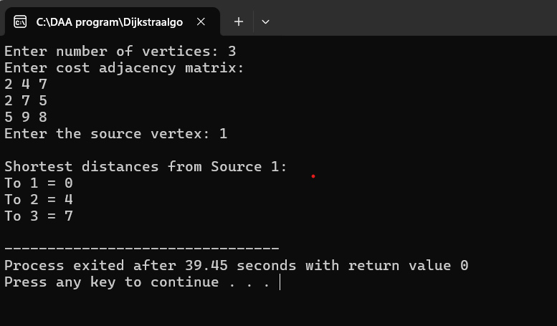

Advantages:
- Finds shortest path efficiently for positive weighted graphs.
- Guarantees optimal result (no negative edge errors).
- Works well for dense graphs using matrix representation.
Disadvantages:
- Cannot handle negative edge weights.
- Inefficient for large graphs if not implemented with priority queue.
- Requires extra memory for distance and visited arrays.
Applications:
- GPS and navigation systems (Google Maps).
- Routing protocols in computer networks.
- Telecommunication and transportation network design.
- AI pathfinding (robotics and games).
Conclusion:
Dijkstra’s Algorithm efficiently computes the shortest path from a source vertex to all other vertices in a weighted, connected graph using a Greedy approach.
It is one of the most reliable methods for real-world routing and network optimization

Experiment No.7
Optimal Binary Search Trees using Dynamic Programming Reg.No.24141056.
Program:
#include <stdio.h>
#define MAX 10
#define INF 9999
int main() {
int n, i, j, k;
float p[MAX], q[MAX], w[MAX][MAX], c[MAX][MAX];
int r[MAX][MAX];
printf("Enter number of keys: ");
scanf("%d", &n);
printf("Enter probabilities of keys (p1 to p%d):\n", n);
for (i = 1; i <= n; i++)
scanf("%f", &p[i]);
printf("Enter probabilities of dummy keys (q0 to q%d):\n", n);
for (i = 0; i <= n; i++)
scanf("%f", &q[i]);
for (i = 0; i <= n; i++) {
w[i][i] = q[i];
c[i][i] = 0;
r[i][i] = 0;
}
for (int m = 1; m <= n; m++) {
for (i = 0; i <= n - m; i++) {
j = i + m;
w[i][j] = w[i][j - 1] + p[j] + q[j];
float min = INF;
int min_k = 0;
for (k = i + 1; k <= j; k++) {
float cost = c[i][k - 1] + c[k][j];
if (cost < min) {
min = cost;
min_k = k;
}
}
c[i][j] = w[i][j] + min;
r[i][j] = min_k;
}
}
printf("\nOptimal Cost of Binary Search Tree: %.2f\n", c[0][n]);
printf("Root of the OBST: %d\n", r[0][n]);
return 0;
}
Output:
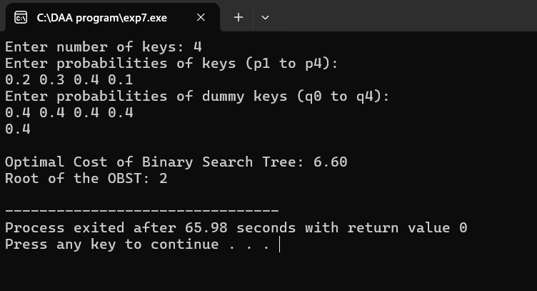
Time Complexity :
The outer loop (m) runs n times.
The middle loop (i) also runs roughly n times (depending on m).
The innermost loop (k) runs up to n times (for each range).
So total operations ≈ O(n × n × n) = O(n³)
Space Complexity :
Because we use 2D matrices w[][], c[][], and r[][] of size n x n : O(n²) Real-Time Applications :
Compiler Design:
Used in symbol table organization to minimize average search time.
Database Indexing
For faster access to records with different search probabilities.
Search Optimization:
Used when different items have different frequencies of search.
Speech and Pattern Recognition:
Helps in optimizing search structures in probabilistic models.
Decision Trees in AI:
OBST concept is used for probabilistic decision making.

Experiment No.8
All-Pairs Shortest Paths Problem using Floyd’s Algorithm
Reg.No.24141056
Program :
#include<stdio.h>
#define V 4
#define INF 9999
void printSolution(int dist[V][V]){
printf("The following matrix shows the shortest distances:\n");
for(int i=0;i<V;i++){
for(int j=0;j<V;j++){
if(dist[i][j]==INF)printf("INF ");
else printf("%3d ",dist[i][j]);
}
printf("\n");
}
}
void floydWarshall(int graph[V][V]){
int dist[V][V];
for(int i=0;i<V;i++)
for(int j=0;j<V;j++)
dist[i][j]=graph[i][j];
for(int k=0;k<V;k++)
for(int i=0;i<V;i++)
for(int j=0;j<V;j++)
if(dist[i][k]+dist[k][j]<dist[i][j])
dist[i][j]=dist[i][k]+dist[k][j];
printSolution(dist);
}
int main(){
int graph[V][V]={{0,8,INF,1},{INF,0,1,INF},{4,INF,0,INF},{INF,2,9,0}};
floydWarshall(graph);
return 0;
}
Output:
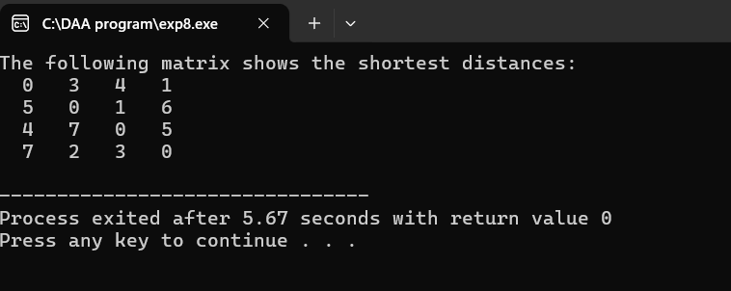
Time Complexity:
Each of the three loops (k, i, j) runs from 0 to V-1.
So total steps ≈ V × V × V = V³ Time Complexity = O(V³)
Space Complexity:
We store a V × V matrix (dist[V][V]).
Space Complexity = O(V²)
Real-Applications :
1.Google Maps / GPS Navigation
Used to find the shortest travel distance between all pairs of cities or locations.
Helps compute the minimum route between any two points on a map.
2.Airline Route Planning
Used to determine minimum connecting flight distances between airports. Helps airlines optimize flight routes and fuel usage.
3. Social Network Analysis Used to find the shortest link or connection between two people in a social graph. Measures how closely users are connected (like degrees of separation).
4. Urban Transportation Systems Used to design shortest bus, metro, or road paths in cities. Improves time efficiency and reduces congestion.
5. Game Development (AI Pathfinding) Used by non-player characters (NPCs) to find the shortest route to reach a target.
Improves movement and strategy in games.

EXPERIMENT NO.9
Graph Colouring Problem Using Back Tracking
Reg. No.:-24141056
Program:-
#include <iostream>
#include <vector>
using namespace std;
bool isSafe(int v, vector<vector<int> >& graph, vector<int>& color, int c) {
for (int i = 0; i < graph.size(); i++) {
if (graph[v][i] && color[i] == c)
return false;
}
return true;
}
bool graphColoringUtil(vector<vector<int> >& graph, int m, vector<int>& color, int v) {
if (v == graph.size())
return true;
for (int c = 1; c <= m; c++) {
if (isSafe(v, graph, color, c)) {
color[v] = c;
if (graphColoringUtil(graph, m, color, v + 1))
return true;
color[v] = 0;
}
}
return false;
}

bool graphColoring(vector<vector<int> >& graph, int m) {
int V = graph.size();
vector<int> color(V, 0);
if (!graphColoringUtil(graph, m, color, 0)) {
cout << "\nNo solution exists." << endl;
return false;
}
cout << "\nSolution exists! Assigned colors: ";
for (int i = 0; i < V; i++)
cout << color[i] << " ";
cout << endl;
return true;
}
int main() {
int V;
cout << "Enter number of vertices: ";
cin >> V;
vector<vector<int> > graph(V, vector<int>(V));
cout << "\nEnter adjacency matrix (" << V << "x" << V << "):\n";
for (int i = 0; i < V; i++) {
for (int j = 0; j < V; j++) {
cin >> graph[i][j];
}
}
int m;
cout << "\nEnter number of colors: ";
cin >> m;
graphColoring(graph, m);
return 0;
}
Output:
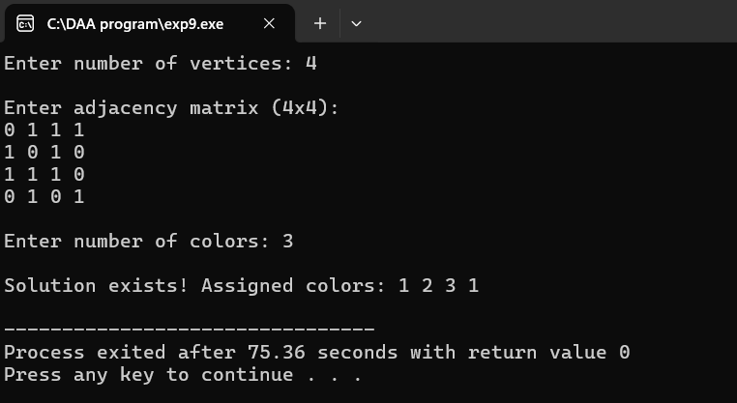
Algorithm :-
Input: A graph G(V, E) represented as an adjacency matrix. Number of colours m. Output: A colour assignment for each vertex such that no two adjacent vertices have the same colour, or report failure
Step 1: Initialize an array color[V] to 0 (no colours assigned).
Step 2: Call the recursive function solve(v) starting with vertex v = 0.
Step 3:
solve(v):
1. If v == V, all vertices are coloured → return true.
2. For each colour c in {1, 2, …, m}:
1. If isSafe(v, c) is true:Assign color[v] = c.If solve(v + 1) returns true, return true.Else, reset color[v] = 0 (backtrack).
3. If no valid colour is found, return false.
Step 4:isSafe(v, c):For every vertex i adjacent to v, if graph[v][i] == 1 and color[i] == c, return false.Return true if no conflicts exist.
Step 5:If solve(0) returns true, output the color[] array;
else, output "No solution exists".
Time Complexity: O(m^V)
Space Complexity: O(V)
List of Applications:-
1. Register allocation in compilers
2. Scheduling problems
3. Map colouring
4. Frequency assignment in mobile networks
5. Timetable scheduling
EXPERIMENT NO.10
Sum Of Subset Problem
Reg. No.:-24141056
Program:-
#include <iostream>
#include <vector>
using namespace std;
bool isSubsetSumDP(vector<int>& set, int sum, vector<int>& subset) {
int n = set.size();
vector<vector<bool> > dp(n + 1, vector<bool>(sum + 1, false));
for (int i = 0; i <= n; ++i)
dp[i][0] = true;
for (int i = 1; i <= n; ++i) {
for (int j = 1; j <= sum; ++j) {
if (set[i - 1] > j)
dp[i][j] = dp[i - 1][j];
else
dp[i][j] = dp[i - 1][j] || dp[i - 1][j - set[i - 1]];
}
}
if (!dp[n][sum])
return false;
int j = sum;
for (int i = n; i > 0 && j > 0; --i) {
if (!dp[i - 1][j]) {
subset.push_back(set[i - 1]);
j -= set[i - 1];
}
}
return true;
}
int main() {
int n, sum;
cout << "Enter the number of elements in the set: ";
cin >> n;
vector<int> set(n);
cout << "Enter the elements of the set: ";
for (int i = 0; i < n; ++i)
cin >> set[i];
cout << "Enter the desired sum: ";
cin >> sum;
vector<int> subset;
if (isSubsetSumDP(set, sum, subset)) {
cout << "Subset found with the given sum:\n";
for (int i = 0; i < subset.size(); i++)
cout << subset[i] << " ";
cout << endl;
} else {
cout << "No subset with the given sum exists." << endl;
}
return 0;
}Algorithm:- Input:Set of positive integers S = {s₁, s₂, …, sₙ}
Target sum d.
Output:-All subsets of S whose elements sum to d
Step 1: Sort the set S (optional for optimization).
Step 2: Initialize variables: sum = 0, k = 0 (starting index).
Step 3: Call subset(k, sum) recursively.
Step 4:
Subset(k, sum):
1. If sum == d: Print current subset; return.
2. If sum > d or k >= n: Return (backtrack).
3. Include S[k] in subset and call subset(k + 1, sum + S[k]).
4. Exclude S[k] and call subset(k + 1, sum). Time Complexity: O(2ⁿ) Space Complexity: O(n)
List of Applications:-
1. Knapsack problem
2. Resource allocation
3. Budget planning
4. Cryptography
5. Load balancing
6. Data partitioning
7. Combinatorial optimization
8. Decision support systems
9. Scheduling tasks
10. Power set generation
Output:
